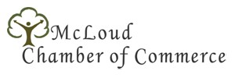

PO Box 254 215 South 6th Street 405-964-6566
McLoud, OK 74851 www.mcloudchamber.com director@mcloudchamber.com

On behalf of the McLoud Chamber of Commerce, I would like to invite you to participate in the 2013 McLoud Blackberry Festival parade! It will be great fun for everyone. We want walkers, riders, floats, bands and cars! Come share your unique hobby, group, or talents with us! The parade will take place on Saturday, July 7 at 10:00 a.m. Participants are asked to arrive no later than 9:00 a.m. for final registration and lineup. The registration desk will be open by 7:00 a.m.

Enclosed is a registration form. You may pre-register by mail to PO Box 254 McLoud, email to Festival@mcloudchamber.com or bring it to Lauren at the McLoud Clinic Pharmacy at 704 South 8th Street, McLoud. If you cannot pre- register, bring it with you to the registration desks located in the McLoud High School Gymnasium on parade day. Use the area at the bottom to provide a narrative about your group that you would like to have announced as you pass the reviewing stand. Our hope is that by providing this to you ahead of time you will be able to prepare according to the needs of your specific group.
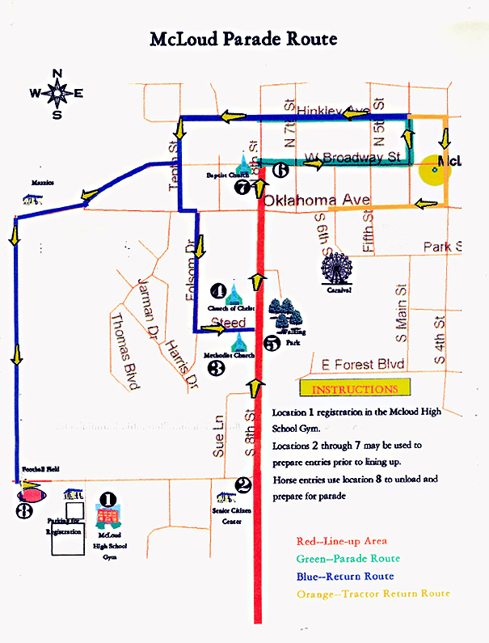
Upon arrival to McLoud, please report to the gym (see map) for final registration and assignment of your line up and location number. Location numbers will be clearly marked in orange on 8th Street.

We sincerely hope you will come and join the fun. Should you have any questions please do not hesitate to contact us at 405-964-6566 or 405-618-2567

Sincerely,

Lauren Palmer
Parade Coordinator
McLoud Chamber of Commerce

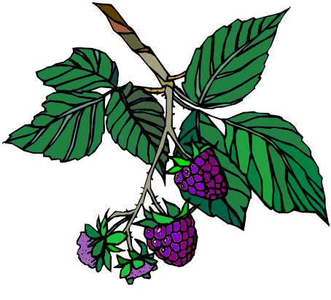
McLoud Blackberry Festival
Parade Registration Form 2013
P.O. Box 254
McLoud, OK 74851
(405) 964-6566

Please Print
Business or Organization Name:__________________________________________________________
Contact Person: _____________________________________ Phone: ___________________________
Address: ____________________________________________________________________________
City: ____________________________________________ State: _______________ Zip:____________
E-mail Address: ________________________________________________________________________
No Registration Fee – Winners will be announced from the main Festival stage at 5pm
The 2013 Festival theme is Wild About McLoud.
1st and 2nd place in each category receives a ribbon *Categories are not judged
Categories – Please Circle One
Float Autos Antique Tractors Horses Walkers
Bikes, 4wheelers, Golf Carts, Motorcycles *Pageant Candidates *Politicians *Other
Dimensions of Entry: _____________________________
Will there be walkers with your group? Yes No If yes, how many: ___________
Entries will be judged on the following criteria: Originality/Use of Art, Overall Appeal

Assigned Numbers must be displayed on passenger side of windshield
Please use the following space to provide a narrative about your entry for the announcers. This must be filled in or no announcement will be made at review stand. Please PRINT and keep announcements brief. (May be edited)

PARTICIPANT, PARENT, GUARDIAN WAIVER AND INDEMNITY AGREEMENT
Program--Activity: McLoud Blackberry Festival Parade Date: _________________

Participant: _____________________________________________________________
In consideration of your accepting the above named entry for participation in the McLoud Blackberry Festival Parade. The above named entry hereby, for myself, my heirs, executors, and administrators, waive and release any and all rights and claims for damages that I may have against the above-named organization and its agents, employees, representatives, successors and assigns for any and all injuries suffered by the above named entry that arise out of the participation in the Blackberry Festival sponsored by the McLoud Chamber of Commerce.

I warrant that I have the right to authorize the foregoing and do hereby agree to hold the above-named organization harmless of and from any liability of whatever nature, which may arise out of or result from such participation.
For the consideration stated above, I further agree that in the event that the above named entry or its participants should make any claim against the McLoud Chamber of Commerce for damages arising out of participation in the Blackberry Festival Parade I will personally indemnify, defend, and hold harmless the organization and its agents, employees, representatives, successors, and assigns against any and all loss and damage occasioned thereby, including attorney’s fees.
I have read and understand this agreement and have willingly placed my signature below as evidence of my acceptance of all the conditions contained herein.

SIGNATURE: _________________________________ Title ___________________________
(Authorized Representative)

Date: _____________________________________

